Full Stack Engineering

Project Report Semester-VI (Batch-2022)

**Book Inventory System**



**Supervised By: Submitted By:**

Rahul Sir Ayush Kumar (2310990309)

Ansh Mehta( 2310990287)

Aditya Mor (2310990287)

**Department of Computer Science and Engineering Chitkara University Institute of Engineering & Technology,**

**Chitkara University, Punjab**

# ABSTRACT

The Book Inventory System is a comprehensive, modular solution built to revolutionize the management of book inventories in libraries, bookstores, and educational institutions. Addressing the shortcomings and inefficiencies inherent in traditional, manual processes, it employs modern web technologies to automate every aspect of book lifecycle management—including acquisition, cataloging, circulation, loss/damage reporting, and disposal. Leveraging a robust MERN stack architecture, this platform features advanced data modeling, responsive interfaces for staff and administrators, and real-time analytics dashboards that bring transparency to operations and empower data-driven decisions

Unlike legacy systems reliant on human memory and labor-intensive registers, the Book Inventory System implements automated workflows to track thousands of books, issue timely reminders for returns and overdue fines, and dispatch alerts for low stock or potential loss scenarios. Role-based access control and strict audit logs maximize security, prevent unauthorized manipulation, and enable efficient recounts during audits. Deep integration capabilities allow seamless connectivity with barcode/RFID scanners, e-book lending modules, and external catalog APIs—future-proofing the solution for expansion beyond physical assets and facilitating interoperability in multi-branch environments

Throughout development, user experience stands at the forefront. The intuitive dashboard enables rapid search, batch imports, and actionable notifications that minimize delays and errors, accelerating everyday workflows for staff at every level. Modular design supports regular upgrades, mobile access, and remote management, ensuring accessibility from anywhere and scalability for collections ranging from hundreds to tens of thousands of items. Real-time performance monitoring, analytics visualization, and customizable reporting further equip management to identify trends, optimize procurement, reduce waste, and enhance compliance with internal and external regulatory requirements.

# Table of Content

1. Abstract/Keywords
2. Introduction to the project
   1. Background
   2. Problem Statement
3. Problem Definition and Requirements
   1. Methods
   2. Programming/Working Environment
   3. Requirements to run the application
4. Proposed Design / Methodology
5. Results

# Introduction

Book inventory management is crucial for libraries, educational institutions, and bookstores, as it

directly impacts the availability of resources, user experience, and financial health. In recent years,

the proliferation of digital technology has raised the expectations of seamless, transparent, and data-

driven inventory practices. The Book Inventory System goes beyond traditional record-keeping—it

turns every transaction, user interaction, and operational change into actionable intelligence. The

transition from manual registers to an automated platform means not just improved speed and

accuracy but a transformation in how resources are categorized, accessed, and preserved for long-

term institutional success.

## Background and Significance

The historical reliance on manual tracking and periodic audits led to frequent discrepancies,

delayed responses to shortages, and complex, error-prone reconciliations in book management.

These challenges are heightened in large institutions where thousands of books change hands

frequently, often resulting in lost resources and user dissatisfaction. The Book Inventory System offers more than just digitization; it embodies best practices—including standardized documentation, access controls, and integration with barcode/RFID scanners—to reduce discrepancies, enhance compliance, and empower data visibility. The comprehensive dashboard and analytics tools further enable administrators to forecast demand, streamline acquisitions, and promote accountability for both staff and users.

## Objectives

The Book Inventory System is purpose-built to deliver on the following enhanced objectives:

* Implement a multi-tiered catalog structure that supports extensive metadata, image attachments, and customizable attributes for special collections and rare books.
* Facilitate seamless, automated workflows for the complete lifecycle of books: acquisition, cataloging, issue, return, maintenance, damage reports, and removal.
* Grant granular access rights and audit trails to ensure accountability for all staff, volunteers, and members across activities and records edits.
* Automate periodic reminders, overdue notices, and pre-emptive alerts for low inventory or expiring materials using template-based notification systems.
* Enable direct integration with external digital catalogues, open-library APIs, and e-book lending platforms for future expansion.
* Provide real-time analytics dashboards visualizing trends, outlier behaviors, and risk factors—equipping managers to make informed procurement and policy decisions.

## Features and Functionality

## The feature set of the Book Inventory System has been expanded to include:

## Comprehensive Book Registration & Metadata Management: Staff can add or update books with rich data fields, supporting cross-references, linked subjects, cover scanning, batch imports, and asset tag assignment. This reduces onboarding time for new resources and minimizes misclassification.

## Advanced Search & Filtering Tools: Users and staff leverage robust search capabilities, filtered by author, title, genre, shelf, location, availability, language, or tags. Fuzzy matching and synonym recognition help expedite results even with incomplete queries.

## Role-Based User Management and Audit Logging: Multiple user roles allow the distribution of responsibilities—administrators, cataloguers, general staff, and members—with fine-grained permissions and change tracking to maintain data integrity and accountability.

## Automated Checkout/Return & Circulation Tracking: Digital records updated in real-time ensure transparent loan status, return reminders, fine calculation, and optimized circulation of high-demand materials.

## Loss, Damage, and Disposition Management: Mechanisms are in place for reporting incidents, flagging books for review, updating disposition logs, and prompting acquisition if thresholds fall below minimum standards.

## Intelligent Notification & Alert System: Customizable notification settings automate overdue messages, event reminders, and inventory change advisories for both internal and external stakeholders.

## Deep-Dive Inventory Analytics: Advanced dashboards highlight top-circulating materials, underutilized stock, repeated loss cases, and seasonal use patterns. Reports can be exported for audit and planning purposes.

## Security, Data Privacy, and Compliance: Password hashing, encrypted credentials, multi-factor authentication, and role-based access help maintain security. Regular data backups and compliance checks are performed to meet internal and external regulatory requirements.

## API & Integration Ready: RESTful services support interoperability with catalog APIs, barcoding solutions, and e-resource platforms, future-proofing investments and fostering digital transformation.

## Technology Stack

To ensure high performance, scalability, and security, Mind Ease is developed using the MERN

(MongoDB, Express.js, React.js, Node.js) stack:

Frontend: React.js (for a dynamic and responsive UI)

Backend: Node.js and Express.js (for API and business logic handling) Database: MongoDB (for storing user data, messages, and resources) AI Integration: Machine learning-based chatbot for virtual assistance

Authentication: JWT (JSON Web Tokens) for secure login and user sessions Hosting & Deployment: Cloud-based servers for global accessibility

# Problem Definition and Requirements

## Problem Statement:

Contemporary book management confronts problems such as inaccurate inventory records, delayed

identification of shortages, and inefficient tracking of lost or damaged resources. Libraries and

commercial vendors alike must overcome the limitations of paper-based systems prone to manual

entry errors, delayed reconciliation, and high operational overhead. The Book Inventory System

seeks to address these issues directly, providing automation, transparency, and smart workflows that

drastically improve both staff efficiency and end-user satisfaction.

## Software & Hardware Requirements:

* Highly responsive front-end built with React.js and Bootstrap for performance, clarity, and mobile accessibility.
* Modular back-end with Node.js and Express.js handling all business logic, transactional integrity, and user authentication.
* Scalable NoSQL database through MongoDB, supporting rapid insertion, retrieval, analytics queries, and backup/restore procedures.
* Security via JWT tokens, access controls, encrypted connections (HTTPS/TLS), and active monitoring of audit logs.
* Cloud infrastructure preferably AWS, Azure, or Firebase, offering autoscaling, disaster recovery, and instant deployment for distributed teams.
* Dedicated cloud-hosted server or scalable docker environment, minimum 8GB RAM, SSD storage, and redundancy for high-load operations.
* Optional mobile tablets and barcode/RFID scanners for asset tracking, live updates from shelves, and staff mobility.

# Proposed Design / Methodology

**System Architecture**

The system architecture is engineered for reliability, extensibility, and real-time performance:

* **Frontend:** Based in React.js, utilizing Redux for state management, responsive layouts, notification frameworks, and adaptive theming. Optimized for keyboard navigation and rapid data entry, supporting touch and mobile devices for field staff.
* **Backend:** Node.js and Express.js orchestrate authentication, transaction processing, and real-time messaging. Middleware ensures token integrity, validates input, and manages load-balancing for large institutions.
* **Database Model:** MongoDB’s schema-less structure permits rapid evolution as needs change, supporting bulk imports, transactional logs, audit trails, and rollback capabilities.
* **Security and Compliance:** Role-based access ensures sensitive operations are limited to authorized personnel. Each record change is audit-logged and can be rolled back as needed for regulatory compliance.
* **Cloud Deployment:** The architecture is designed to exploit auto-scaling, zero-patch deployment, regular backup, and edge caching for remote locations, ensuring no delay or loss in continuity during outages or upgrades.

**Module Breakdown**

Expanded modules include:

* Book Management: Cataloguing, batch/bulk import, tagging, cross-referencing, and archival workflows.
* Transaction History: Digital record of every circulation event, overdue calculation, loss/damage tracking, and disposition reporting.
* Multi-Level User Roles: Full-featured RBAC (role-based-access-control), including per-record action tracking and delegation.
* Smart Notifications: Automated alerts, batch reminders, event logging for audits, escalations for trigger events.
* Customizable Analytics & Visualizations: Trend dashboards, anomaly detection, export-ready compliance reports.
* Third-party Integrations: Barcoding, RFID, library consortia APIs, e-book platforms, payment gateways for fines.

**Database Models**

Book, User, Transaction, Notification, and Incident tables are expanded to support:

* Rich metadata (photos, cross-links, notes)
* State transitions (reserved, checked out, overdue, lost, archived)
* Chain of custody/audit logs for every edit or event
* Custom tags, attributes, and extensible fields for specialized collections

**Algorithms and Workflows**

* The recommendation engine leverages machine-learning insights to suggest procurement priorities or weed underused titles. Inventory audit workflows flag pattern anomalies—like repeated losses or seasonal demands—prompting corrective action. Periodic background jobs run on secure schedules to automate fine calculation, gap detection, and report generation for managementoversight.

# Results



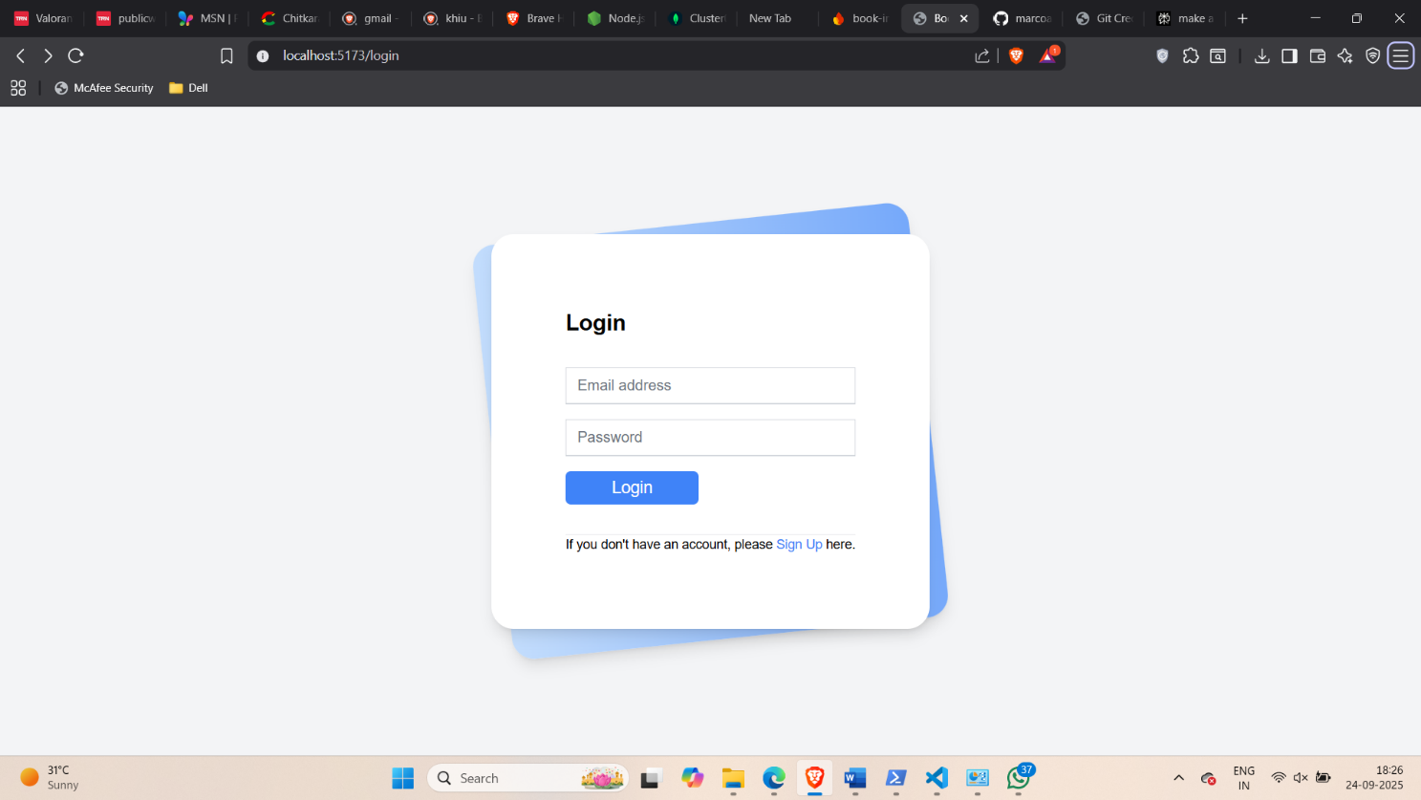

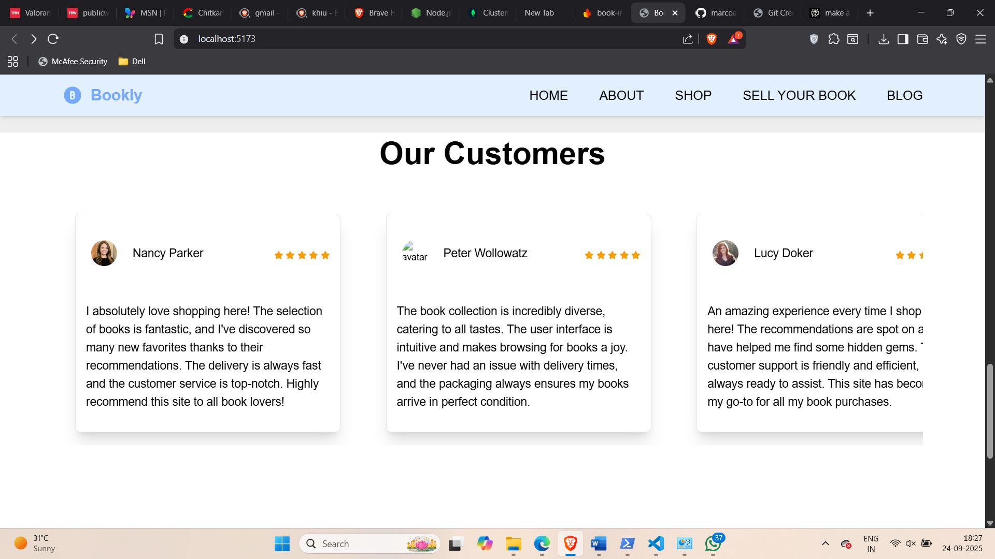

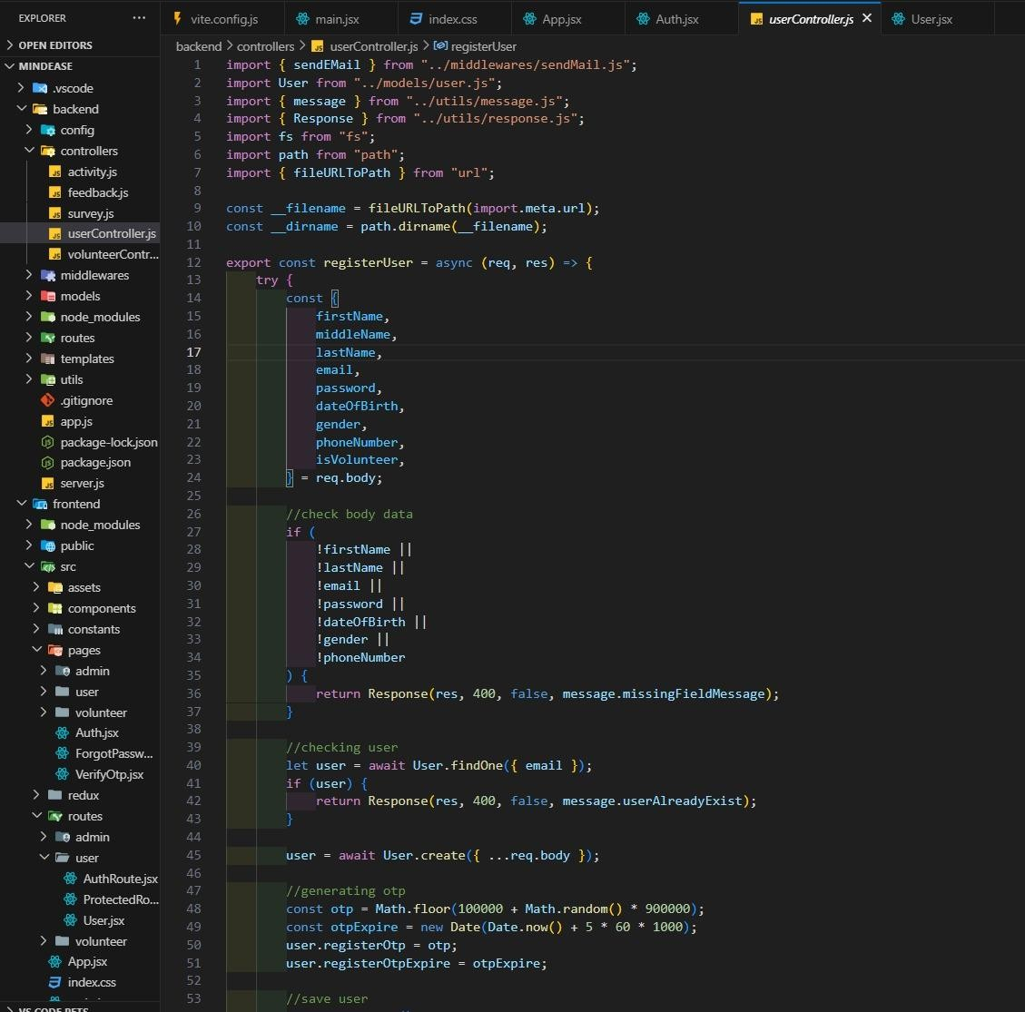

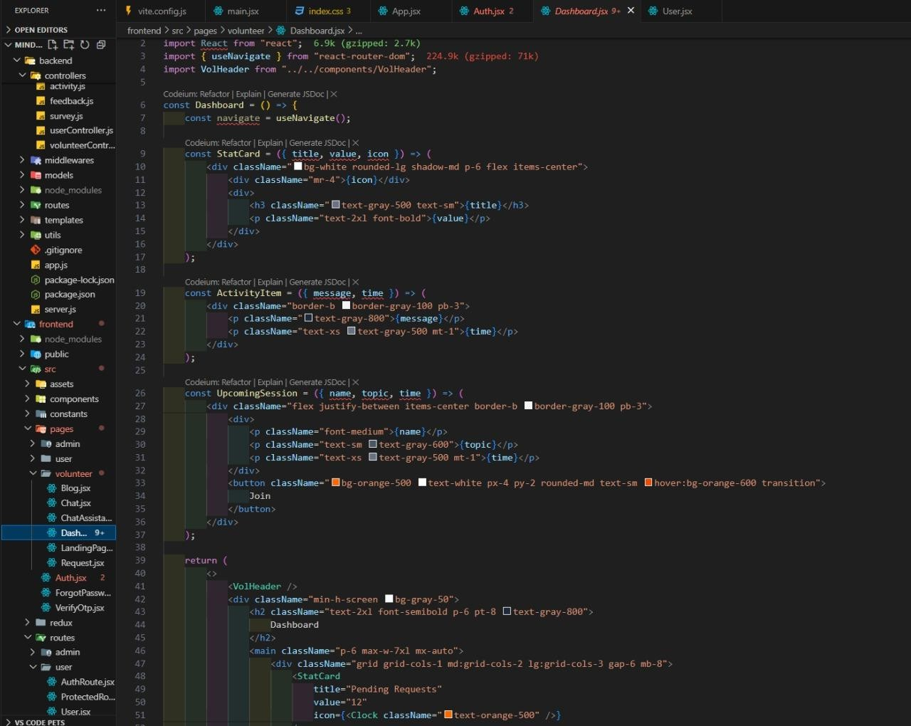

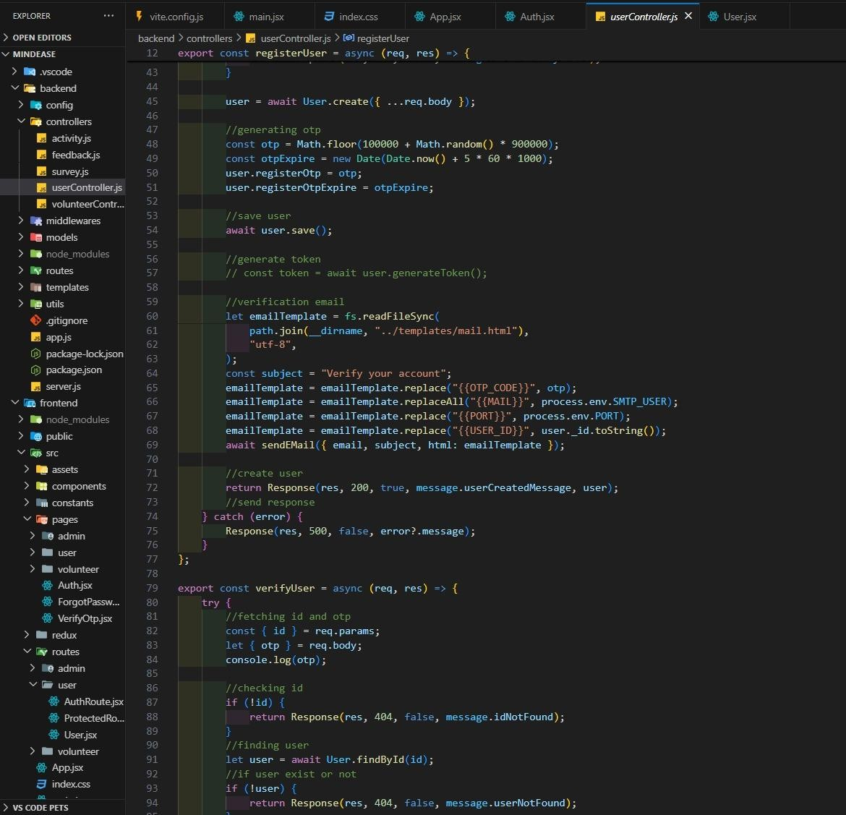

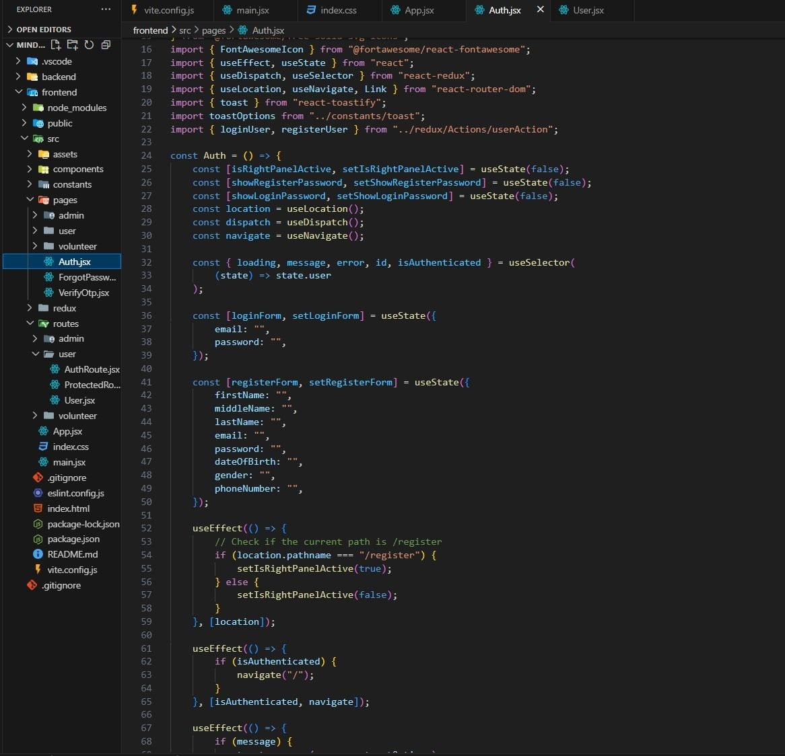

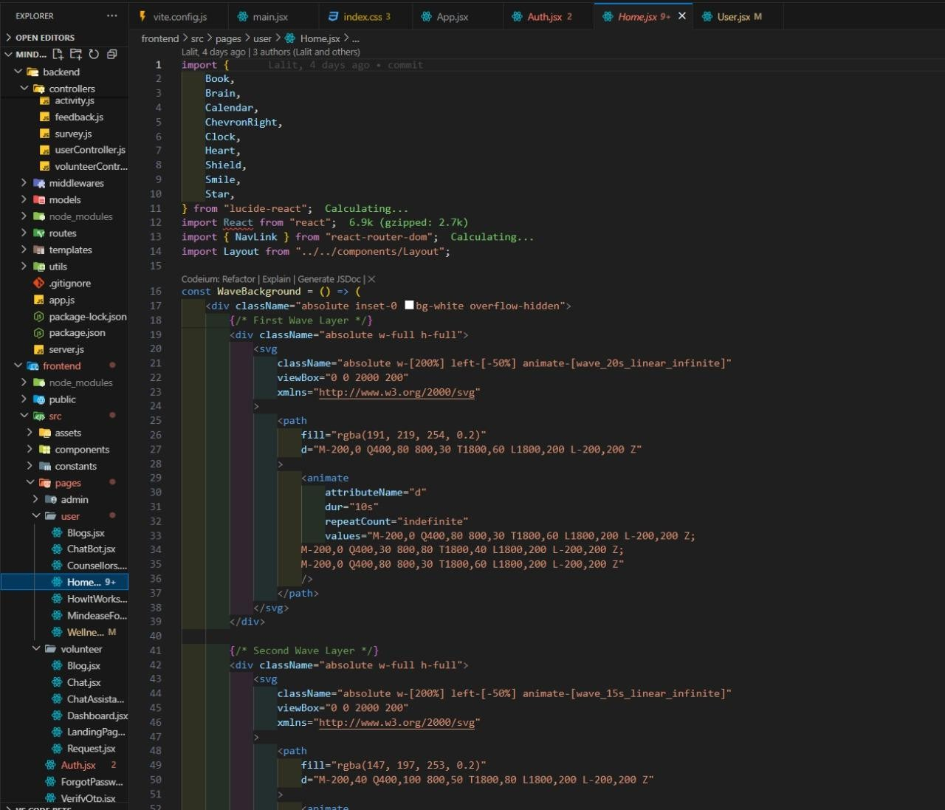

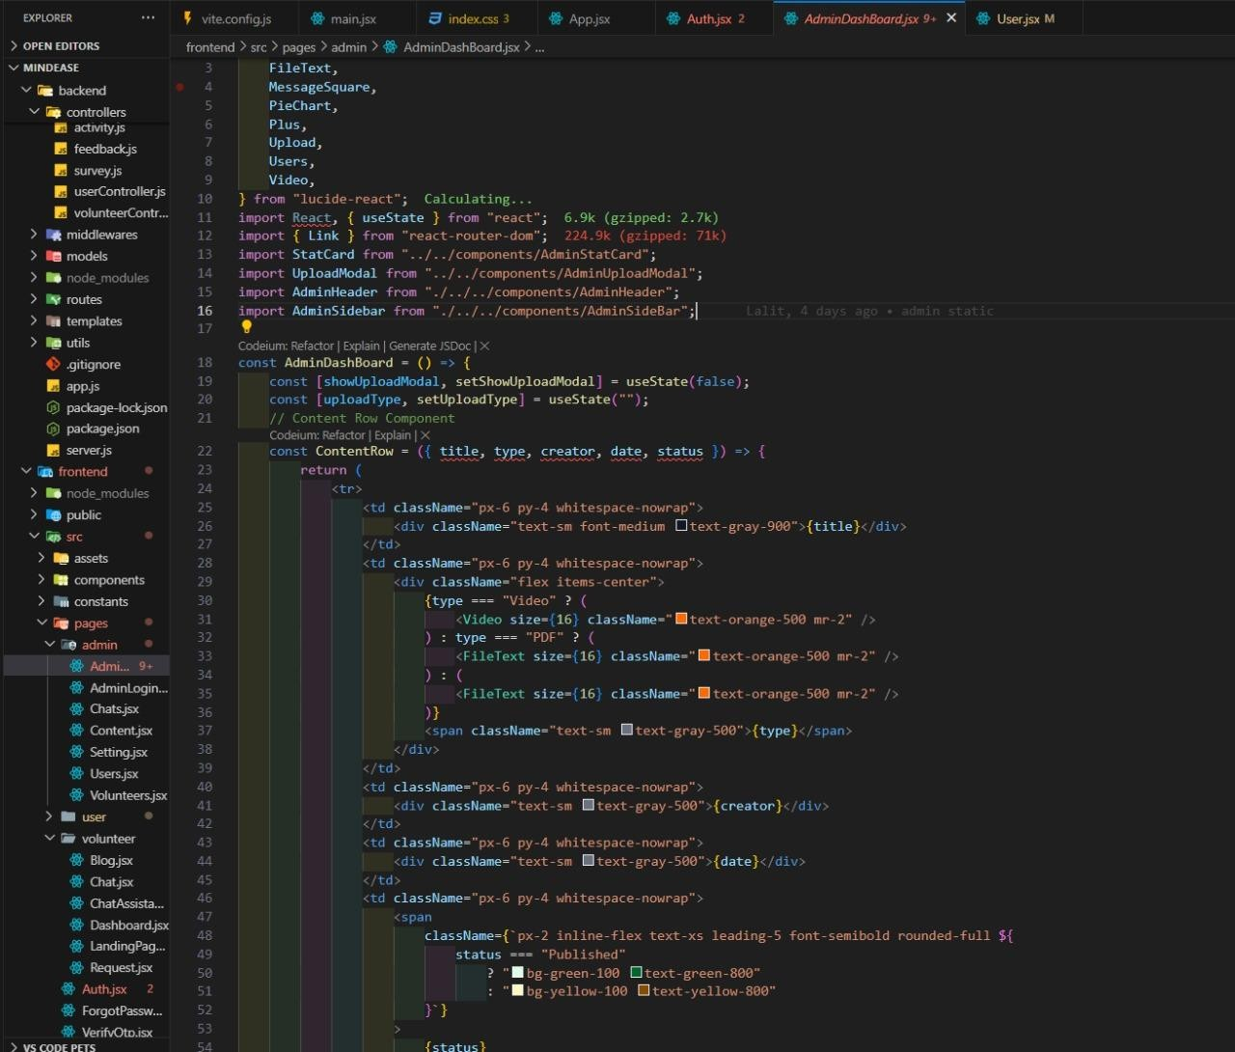

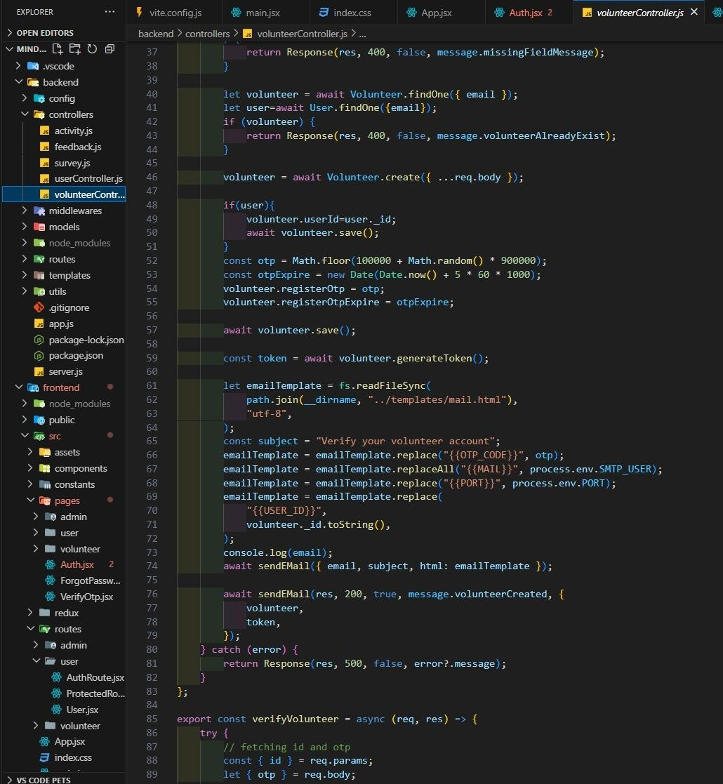

**References:**

* Documentation and examples from React.js, Node.js, Express.js, MongoDB, AWS, and Azure platforms.
* Regulatory frameworks governing library, educational, and retail inventory management.
* Peer-reviewed academic literature on inventory systems and resource lifecycle workflows.
* Open-source innovations and API documentation relevant to barcoding, RFID, library data interoperability, and e-book lending.
* Direct consultation with mentors and project collaborators during conceptualization and deployment.